AI EMAIL WRITER USING STREAMLIT AND GROQ API
Abstract:
The AI Email Writer is a web-based application that helps users generate professional emails quickly and easily. The user provides inputs such as the purpose of the email, desired tone, and key points. The system uses artificial intelligence through the Groq API and LLaMA model to generate structured email content.
The application produces multiple outputs including a professional email, a follow-up email, a short version, and subject line suggestions. It is built using Streamlit for the user interface and Python for backend processing.
This project reduces the time and effort required for writing emails and ensures proper formatting and tone. It is especially useful for students and professionals who need quick and effective communication.
The system works by converting user inputs into a structured prompt, which is then processed by the AI model to generate meaningful and context-aware email content. The generated emails maintain clarity, professionalism, and relevance based on the selected tone and purpose. This ensures that users can rely on the application for different communication scenarios such as job applications, leave requests, business communication, and follow-ups.
In addition, the application is designed with a simple and user-friendly interface, making it accessible even for users with minimal technical knowledge. The use of secure environment variables helps in protecting sensitive data such as API keys. The project also demonstrates how modern AI technologies can be integrated into real-world applications to improve efficiency and productivity.
Although the system provides accurate and structured outputs, its performance depends on the quality of the input provided by the user. It also requires an active internet connection and is subject to API usage limitations. Future improvements can include features like multi-language support, voice input, email sending functionality, and enhanced customization options.

OBJECTIVE
- To develop a simple web application that generates emails automatically using AI
This project aims to create an easy-to-use web application that can automatically generate emails using artificial intelligence, reducing the need for manual writing.

- To allow users to input purpose, tone, and key points easily
The system provides a user-friendly interface where users can quickly enter the purpose of the email, select the tone, and add important points without any technical difficulty.

- To generate multiple email formats (professional, follow-up, short version)
The application is designed to produce different versions of emails such as a detailed professional email, a follow-up email, and a short version, giving users flexibility in communication.

- To reduce time and effort in writing emails manually
By automating the email writing process, the system helps users save time and effort, especially in professional and academic scenarios.

- To ensure proper structure and tone in email communication
The AI ensures that the generated emails follow a proper format with correct tone and structure, improving the overall quality of communication.

- To implement the system using Streamlit and Groq API
The project utilizes modern technologies like Streamlit for building the interface and Groq API for AI-powered email generation, making the system efficient and scalable.

TECHNOLOGIES USED
- Frontend: Streamlit
Used to build a simple and interactive user interface. It allows users to input data and view generated emails easily.
- Backend: Python
Handles the application logic and processes user inputs. It also manages communication with the AI API.
- Environment Variables: python-dotenv
Used to securely store sensitive data like API keys. It helps keep credentials safe and separate from the code.
- API: Groq
Responsible for generating email content using artificial intelligence. It processes prompts and returns structured responses.
- Model: LLaMA 3
A powerful language model used to generate human-like text. It understands user input and creates meaningful email content.

SYSTEM ARCHITECTURE

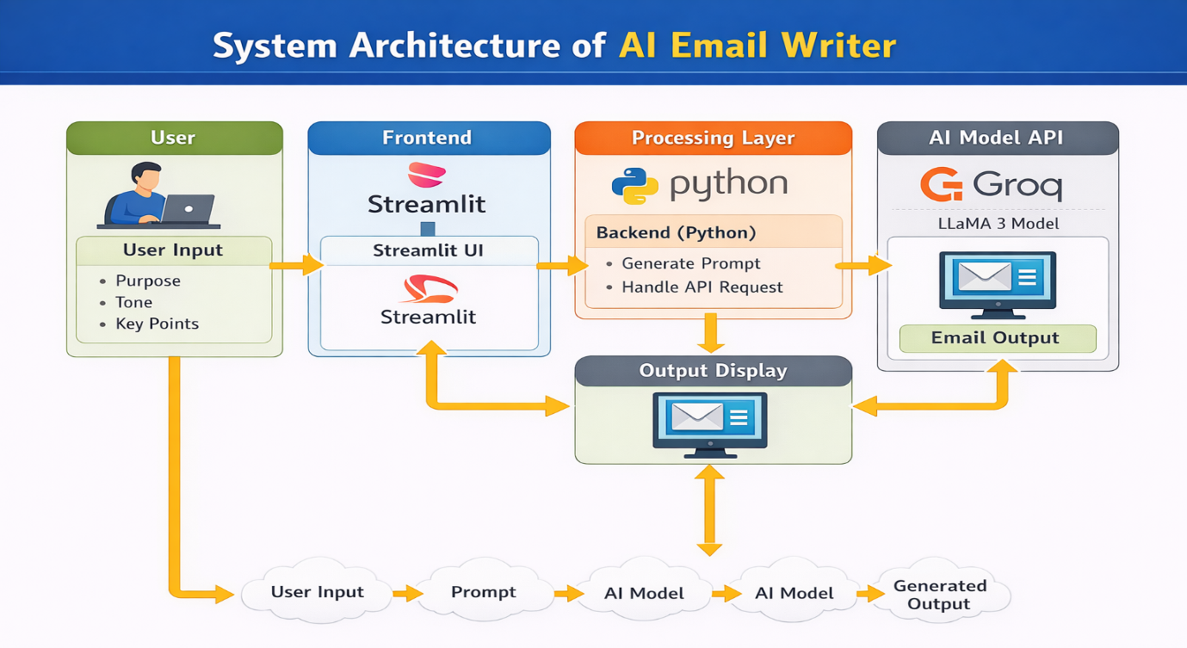
Components:
- User Interface (Frontend)
- Built using Streamlit
- Takes user input (purpose, tone, key points)
- Backend (Processing Layer)
  - Developed in Python
  - Creates structured prompts from user input
  - Handles API requests and responses
- AI Model API
  - Uses Groq API
  - Processes prompt using LLaMA model
  - Generates email content
- Output Display
  - Shows generated emails on the Streamlit interface
WORKING PROCESS
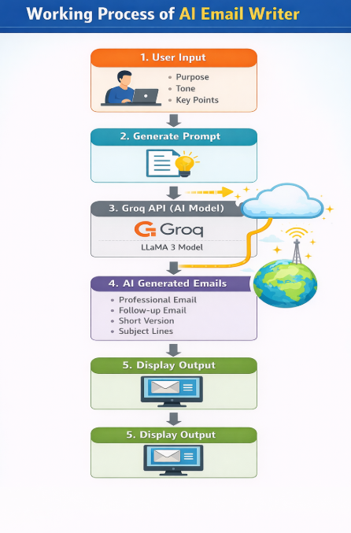
- The user enters the purpose, selects the tone, and provides key points in the application built using Streamlit.
- The system collects these inputs and creates a structured prompt.
- The prompt is sent to the AI model through the Groq API.
- The AI model processes the input and generates:
  - Professional Email
  - Follow-up Email
  - Short Version
  - Subject Line Suggestions
- The generated output is displayed on the screen for the user.
CODE EXPLANATION
- load_dotenv () → Loads API key securely
- Groq (api_key=...) → Connects to AI model
- st.text_input () → Takes purpose
- st. selectbox () → Selects tone
- st.text_area () → Input points
- st. button () → Runs generation
- client. chat. completions. create () → Calls AI
ADVANTAGES
- Saves time by generating emails instantly
- Easy to use with a simple interface built using Streamlit
- Generates well-structured and professional emails
- Supports different tones like formal, friendly, apology, and request
- Provides multiple outputs (professional, follow-up, short version, subject lines)
- Reduces effort in writing emails manually
- Uses AI through Groq for better quality content
- Helpful for students, job seekers, and professionals

FUTURE ENHANCEMENTS
- Add more tone options (casual, professional+, persuasive, etc.)
- Support multiple languages for wider usability
- Add download option (PDF/Word format)
- Integrate email sending feature (Gmail/Outlook)
- Improve UI design beyond basic Streamlit layout
- Add voice input for hands-free usage
- Include grammar checking and suggestions
- Use advanced AI models via Groq for better accuracy

Output:
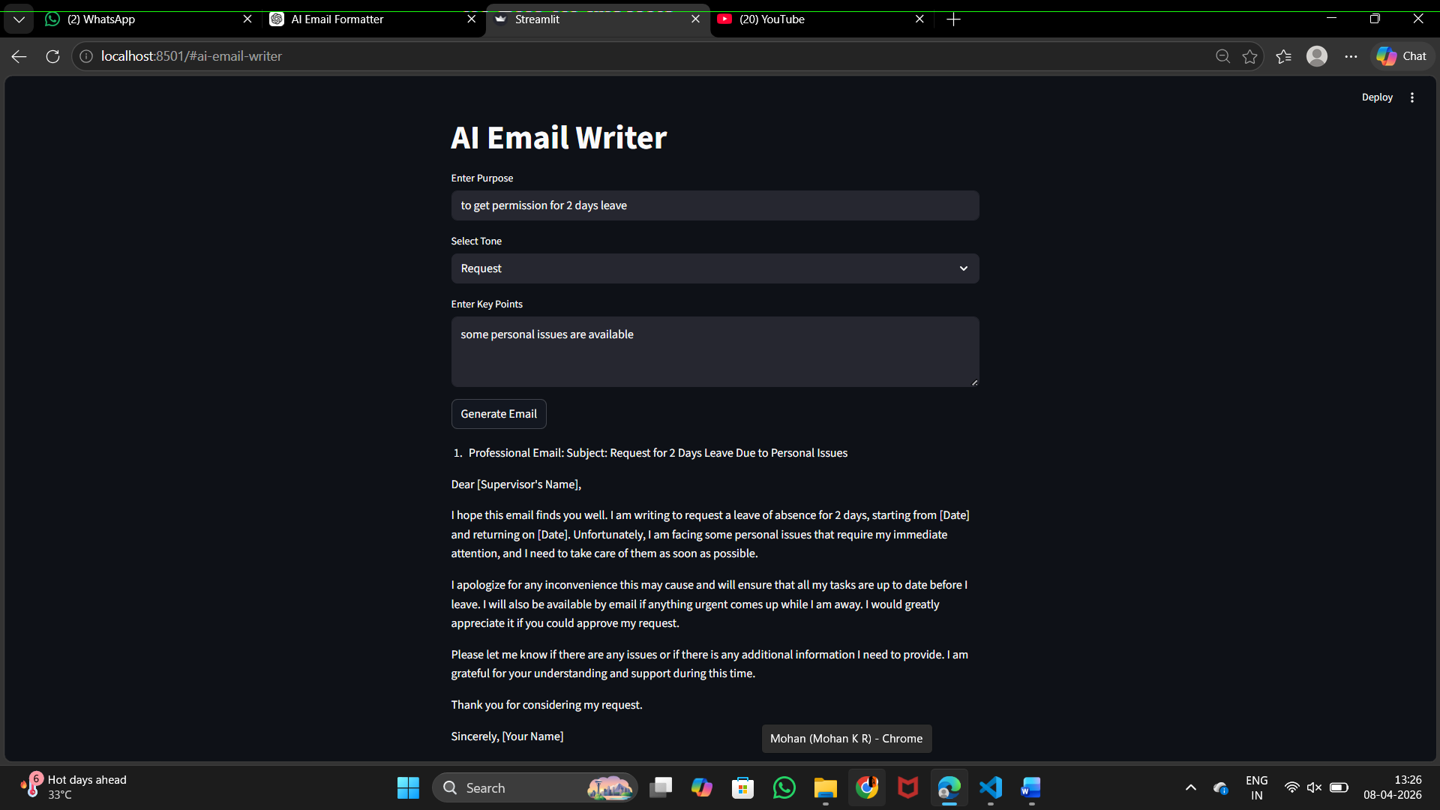
The above screenshot shows the working interface of the AI Email Writer application developed using Streamlit. The user interface is simple and user-friendly, where the user enters the purpose of the email, selects the desired tone (in this case, “Request”), and provides key points related to the email content. After clicking the “Generate Email” button, the system processes the input and generates a structured professional email using the Groq API.
The output section displays a well-formatted professional email along with a subject line. In this example, the system generates a leave request email for two days due to personal issues. The generated email includes proper greeting, body content, and closing, demonstrating the system’s ability to create clear and professional communication based on minimal user input.

DESCRIPTION
The AI Email Writer is a simple and effective application that helps users generate professional emails quickly using artificial intelligence. By using Streamlit for the interface and integrating the Groq API, the system is able to create well-structured emails based on user inputs like purpose, tone, and key points.
Overall, the project demonstrates how AI can simplify everyday tasks and increase productivity, with scope for further improvements and real-world applications.
The application provides multiple outputs such as a professional email, follow-up email, short version, and suggested subject lines, making it useful for different communication needs. It is designed with a user-friendly interface so that even users with basic technical knowledge can easily interact with the system.
The working process involves taking user inputs, converting them into a structured prompt, and sending it to the AI model through the Groq API. The model then processes the request and generates accurate and well-formatted email content within seconds.

